**Ссылка на этот шаблон:**

<https://docs.google.com/document/d/1vTQxKnkziugzPiL8xBoO6_yLRKPZJCAKEsevMCsYwIE/edit?usp=sharing>

**Задание 1: Теория тестирования**

1. Ссылка на гугл-таблицу:

[Егор Калинин — диплом](https://docs.google.com/spreadsheets/d/1-tROgdkv-E09aUz_AGQmbjaKULS7yVeamQZ7lJOf5JI/edit?usp=sharing)

**Задание 2: Веб-приложение Яндекс.Самокат**

1. Mindmap:

[1. Mindmap 2.01.png](https://drive.google.com/file/d/1Cu67ogVVA3LDarlnAnJj5F4iNOO6NIFT/view?usp=sharing)

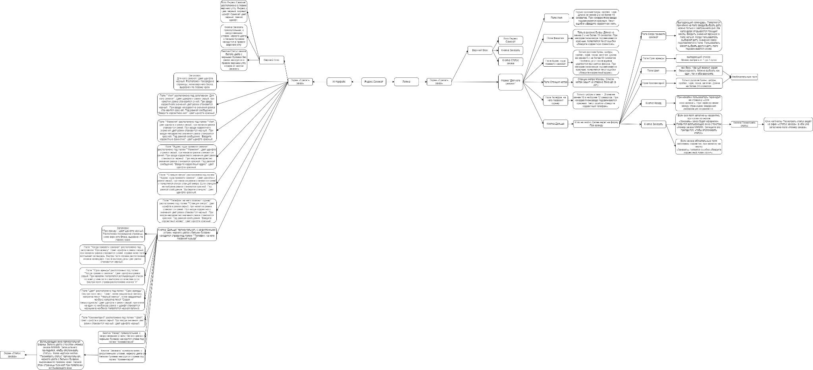

1. Ссылки на баг-репорты, заведённые в трекере:

<https://egorio.youtrack.cloud/issue/ETQ-1>

<https://egorio.youtrack.cloud/issue/ETQ-2>

<https://egorio.youtrack.cloud/issue/ETQ-3>

<https://egorio.youtrack.cloud/issue/ETQ-4>

<https://egorio.youtrack.cloud/issue/ETQ-5>

<https://egorio.youtrack.cloud/issue/ETQ-10>

<https://egorio.youtrack.cloud/issue/ETQ-11>

<https://egorio.youtrack.cloud/issue/ETQ-6>

<https://egorio.youtrack.cloud/issue/ETQ-7>

<https://egorio.youtrack.cloud/issue/ETQ-8>

<https://egorio.youtrack.cloud/issue/ETQ-9>

<https://egorio.youtrack.cloud/issue/ETQ-12>

<https://egorio.youtrack.cloud/issue/ETQ-13>

<https://egorio.youtrack.cloud/issue/ETQ-14>

<https://egorio.youtrack.cloud/issue/ETQ-15>

<https://egorio.youtrack.cloud/issue/ETQ-16>

<https://egorio.youtrack.cloud/issue/ETQ-17>

<https://egorio.youtrack.cloud/issue/ETQ-18>

<https://egorio.youtrack.cloud/issue/ETQ-19>

<https://egorio.youtrack.cloud/issue/ETQ-21>

<https://egorio.youtrack.cloud/issue/ETQ-22>

<https://egorio.youtrack.cloud/issue/ETQ-23>

<https://egorio.youtrack.cloud/issue/ETQ-24>

<https://egorio.youtrack.cloud/issue/ETQ-25>

<https://egorio.youtrack.cloud/issue/ETQ-57>

<https://egorio.youtrack.cloud/issue/ETQ-58>

<https://egorio.youtrack.cloud/issue/ETQ-59>

<https://egorio.youtrack.cloud/issue/ETQ-60>

<https://egorio.youtrack.cloud/issue/ETQ-61>

<https://egorio.youtrack.cloud/issue/ETQ-62>

<https://egorio.youtrack.cloud/issue/ETQ-63>

<https://egorio.youtrack.cloud/issue/ETQ-64>

<https://egorio.youtrack.cloud/issue/ETQ-65>

<https://egorio.youtrack.cloud/issue/ETQ-66>

<https://egorio.youtrack.cloud/issue/ETQ-67>

<https://egorio.youtrack.cloud/issue/ETQ-68>

<https://egorio.youtrack.cloud/issue/ETQ-69>

<https://egorio.youtrack.cloud/issue/ETQ-70>

<https://egorio.youtrack.cloud/issue/ETQ-71>

**Задание 3: Мобильное приложение Яндекс.Самокат**

1. Ссылки на баг-репорты, заведённые в трекере:

<https://egorio.youtrack.cloud/issue/ETQ-26>

<https://egorio.youtrack.cloud/issue/ETQ-27>

<https://egorio.youtrack.cloud/issue/ETQ-28>

<https://egorio.youtrack.cloud/issue/ETQ-29>

<https://egorio.youtrack.cloud/issue/ETQ-30>

<https://egorio.youtrack.cloud/issue/ETQ-31>

<https://egorio.youtrack.cloud/issue/ETQ-32>

<https://egorio.youtrack.cloud/issue/ETQ-33>

<https://egorio.youtrack.cloud/issue/ETQ-72>

<https://egorio.youtrack.cloud/issue/ETQ-73>

<https://egorio.youtrack.cloud/issue/ETQ-74>

<https://egorio.youtrack.cloud/issue/ETQ-75>

<https://egorio.youtrack.cloud/issue/ETQ-76>

**Задание 4: API приложения Яндекс.Самокат**

1. Ссылки на баг-репорты, заведённые в трекере:

<https://egorio.youtrack.cloud/issue/ETQ-34>

<https://egorio.youtrack.cloud/issue/ETQ-35>

<https://egorio.youtrack.cloud/issue/ETQ-36>

<https://egorio.youtrack.cloud/issue/ETQ-37>

<https://egorio.youtrack.cloud/issue/ETQ-38>

<https://egorio.youtrack.cloud/issue/ETQ-39>

<https://egorio.youtrack.cloud/issue/ETQ-40>

<https://egorio.youtrack.cloud/issue/ETQ-41>

<https://egorio.youtrack.cloud/issue/ETQ-42>

<https://egorio.youtrack.cloud/issue/ETQ-43>

<https://egorio.youtrack.cloud/issue/ETQ-44>

<https://egorio.youtrack.cloud/issue/ETQ-45>

<https://egorio.youtrack.cloud/issue/ETQ-46>

<https://egorio.youtrack.cloud/issue/ETQ-47>

<https://egorio.youtrack.cloud/issue/ETQ-48>

<https://egorio.youtrack.cloud/issue/ETQ-49>

<https://egorio.youtrack.cloud/issue/ETQ-50>

<https://egorio.youtrack.cloud/issue/ETQ-51>

<https://egorio.youtrack.cloud/issue/ETQ-52>

<https://egorio.youtrack.cloud/issue/ETQ-53>

<https://egorio.youtrack.cloud/issue/ETQ-56>

<https://egorio.youtrack.cloud/issue/ETQ-54>

<https://egorio.youtrack.cloud/issue/ETQ-55>